

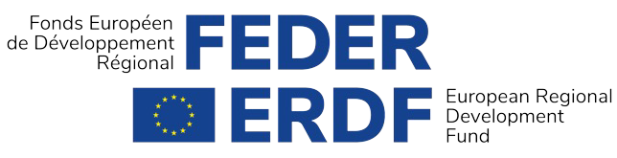

THE IMPORTANCE OF THE PARTNERSHIP BETWEEN THE BRUSSELS-CAPITAL REGION AND THE EUROPEAN UNION

The European cohesion policy is the main tool for investment and solidarity in the EU. Its action is implemented through operational programmes at the regional level (for the ERDF) and is therefore close to the citizens. It aims to reduce the disparities between regions, create and support economic activity and growth, encourage innovation and promote social integration, and therefore directly affects the day-to- day life of the people of Brussels.

The Brussels-Capital Region has chosen to mobilise its resources (contributed in equal parts by the Brussels Region and the European Union), in a 2014-2020 Operational Programme financing investment around economic, social and environmental issues, while improving the quality of life of its population.

More concretely, the Government of the Brussels-Capital Region has selected 58 projects and 3 financial instruments, spread over five priority areas, since May 2015.

195 million euros will be invested by the end of 2023 to:

•

•

•

strengthen innovation and research (pillar 1),

encourage entrepreneurship and the development of SMEs (pillar 2),

support the development of a circular economy and the rational use of resources, by focusing on both a low-carbon economy (pillar 3) and improving the waste/ resources cycle (pillar 3bis),

combating social polarisation (pillar 4).

•

In terms of economic projects, the programme finances five sectors considered priorities because they generate quality jobs:

•

•

•

•

•

health and personal services,

sustainable construction and renewable energies, sustainable food,

resources and waste,

media, creative sectors and tourism.

1

THE «2014-2020» OPERATIONAL PROGRAMME IN THE BRUSSELS-CAPITAL REGION





REACT EU

It should be noted that in 2021, the Programme budget was increased by 6.1 million euros of additional European funds (REACT EU) to provide responses for economic recovery in the context of the health crisis. The allocation of these additional resources will be incorporated into a programme amendment during 2022.

An important clarification regarding the timeline: the ERDF 2014-2020 programming did not end in 2020, but will actually continue until 31 December 2023. 2020 corresponded to the last budgetary commitment at the European level, which must be spent in the following three years. The process of closing the programme will therefore take place in 2024 and 2025, after the last expenditures have been made by the project leaders. These last years will be very useful for implementing what are sometimes very ambitious investments.

THE AIMS OF THE PROGRAMME

The Brussels Region has set a number of objectives for each of the programme’s pillars; in research and innovation, for example, the objective is to support 150 companies and create 16 research positions.

To strengthen entrepreneurship and encourage the development of SMEs, the objective is to support around 500 SMEs and create 14,600 m² of additional infrastructure (renovation, construction).

Regarding the development of a circular economy and the rational use of resources, the goal is to reach 360 companies, decrease the annual energy consumption of public buildings by 8,400,000 KWh/year, and achieve an additional waste recycling capacity of 5,000 tons per year.

Lastly, to improve the living environment, there are plans to create around

10,700 m² of infrastructure, divided between cultural venues, daycare centres and new infrastructure giving people «spaces to live».

2

THE ERDF 2014-2020 PROGRAMMING DID NOT END IN 2020



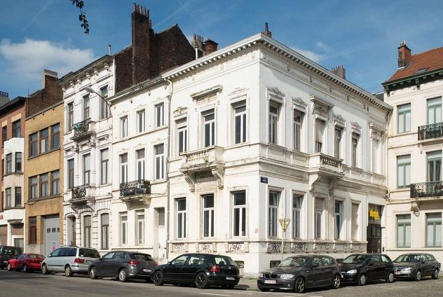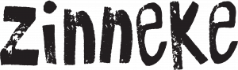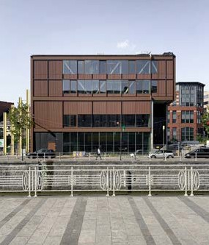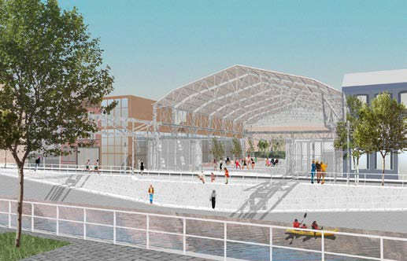

SOME 2021 ACHIEVEMENTS

**COLLECTIVE INFRASTRUCTURES FOR THE PEOPLE OF BRUSSELS**

@ BOGDAN & VAN BROECK

@Zampone-L’Escaut

130 new childcare places were opened in 2021 in two new crèches: Charbonnage (Molenbeek) and ALTAIR (Schaerbeek).

@Christophe Wullus

2,088 m² of space was renovated for the Zinneke project, which now has a permanent home for developing its cultural activities, including the Zinneke parade, which occupies an important place in the hearts of Brussels residents.

3



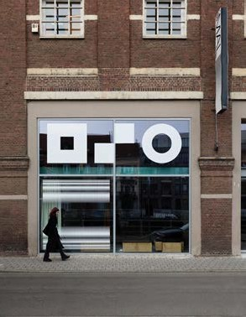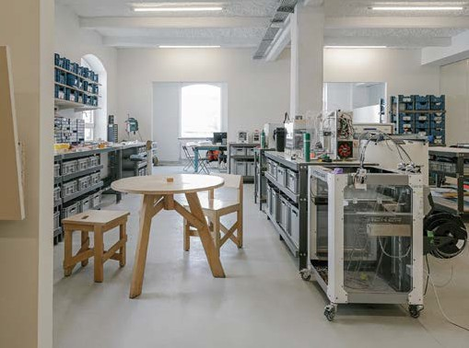

@Eline Willaert

@Eline Willaert

**iMAL/ CASTII**

Creation of a new gallery and public events space within the Centre for Digital Cultures and Technology and expansion of the iMAL Fablab.

4



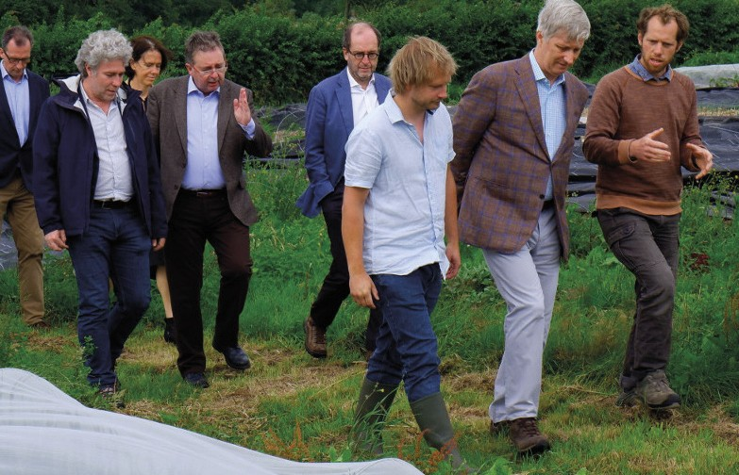

@haricots.org

**BOERENBRUXSELPAYSANS**

**HONOURED by the visit of His Majesty King Philippe**

On 6 July 2021, the BoerenBruxselPaysans project had the honour of welcoming His Majesty King Philippe to the Graines de Paysans agricultural test space. The theme of the day was biodiversity and, after discovering the adjoining Vogelzang nature reserve, our Sovereign was able to meet the market gardeners carrying out the test activity. Urban agriculture is multifunctional; in addition to its production function, it is essential for maintaining biodiversity in

our environment! Over the last six years, the BoerenBruxselPaysans project has stimulated the Region’s transition to sustainable food systems and passed the baton to its partners to continue the movement towards greater resilience through their actions (training, access to land, food, awareness, etc.).

5



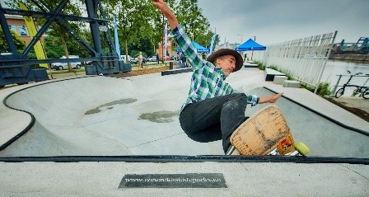

@Port de Bruxelles

**Inauguration of SK8 Port:**

**A SKATE PARK AT THE BRUSSELS CRUISE TERMINAL**

This new skate park, which opened in July 2021 and was built at the initiative of the Port of Brussels, has a surface area of 600 m² and is part of the larger project to develop the left bank of the outer harbour that began with the inauguration in 2018 of the Brussels Cruise Terminal (the new Port of Brussels passenger terminal).

The whole project, the terminal and the skate park, as well as the riverbank, have been landscaped and planted in line with the environmental concerns of the Port of Brussels and thanks to the support of the ERDF.

6



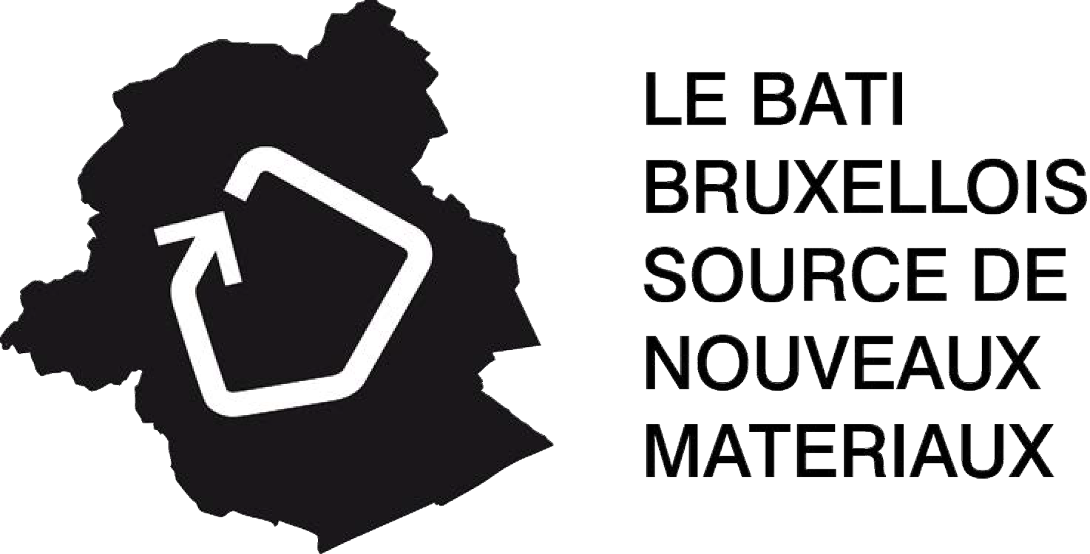

**«THE BRUSSELS BUILDING SOURCE OF NEW MATERIALS», A TOOL FOR THE CONSTRUCTION SECTOR**

In terms of research and innovation, ‘The Brussels Building Source of New Materials (BBSM)’ project - supported by the Scientific and Technical Construction Centre (CSTC), the Vrije Universiteit Brussel (VUB), the Université catholique de Louvain (UCL) and Rotor vzw - has made it possible to develop a tool for the efficient management and exploitation of the - in principle local - «resource» that is

the building stock and the activity of the construction sector in the Brussels-Capital Region. In line with the Region’s sustainable development, this tool encourages the reintroduction of materials at the end of their life cycle, by identifying sites (particularly

demolition sites) whose waste could be reused, as well as recovery techniques, thus limiting the volume of waste. The project was completed in May 2021.

7



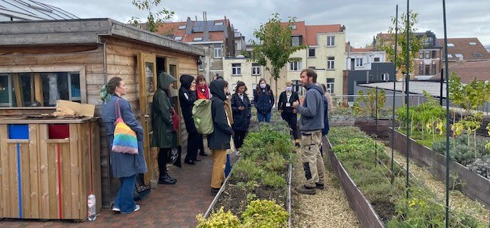

**L[ag]UM A ROOFTOP GARDEN**

The European Week of Regions and Cities (#EURegionsWeek), a major event dedicated to European regional policy in Brussels, was an opportunity to present the L[ag]UM project to the European press as a perfect illustration of the theme of ecological transition. This participatory research-action project, which studies different agroecological practices applicable to rooftops in an urban environment, has become a showcase for education and training on urban agriculture in Brussels. The unique market garden project of

800 m² of cultivable space on a roof (the roof of a store on rue Gray in Ixelles) was developed and co-financed by the Municipality of Ixelles within the framework of the Maelbeek sustainable district contract, which includes the development of the vegetable garden. The Université libre de Bruxelles (ULB), as a scientific partner, is leading the ‘research’ part of the project, while the non-profit organisation Refresh XL is in charge of market garden production, integrating the educational and social dimensions.

Once on the roof, the journalists were led into this urban agriculture laboratory to discover the space and pick some produce. The visit ended with a meal at Refresh XL’s social canteen, which cooks with produce grown on the roof.

8



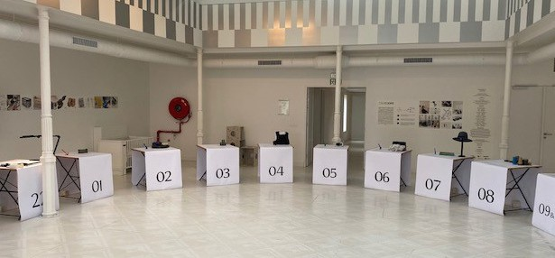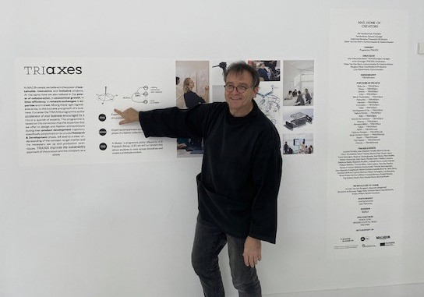

**TRIAXES, A TRINITY OF EXPERTS**

In October 2021, a closing exhibition was held that brought together the achievements, supported since 2015, of the TRIAXES project, led by MAD (Brussels platform for expertise in the Fashion and Design sectors) and the ULB. TRIAXES has encouraged the entrepreneurial process by offering an operational consulting service supervised by a «trinity» of experts from different fields. The supported SMEs, start-ups, spin-offs and self-employed people from Brussels were able to develop mass- produced products or collections in the fashion sector.

9



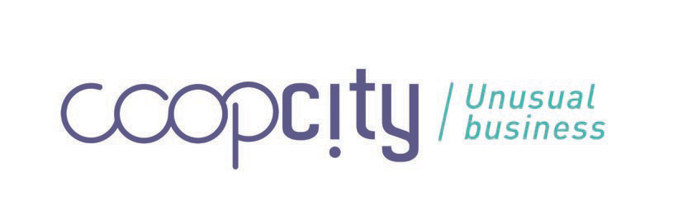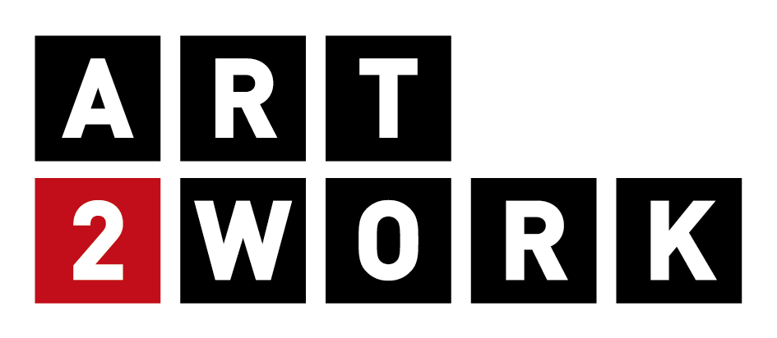

**BELLEVUE4STARTERS AND COOPCITY: CUSTOM MADE AND A NEW ECONOMIC MODEL**

The Bellevue4Starters and COOPCITY projects closed at the end of 2021. The former aims to provide tailor-made support for young adults in search of employment, with a particular focus on the self-creation of employment, in a space located in the former Bellevue Breweries. COOPCITY has succeeded in creating a cooperative and collaborative social entrepreneurship centre, which has supported a large number of projects by developing a new economic model. It should be noted that a festive event is planned for 2022 and that these two projects are assured of sustainability, since their programmes will continue beyond the ERDF programme.

10



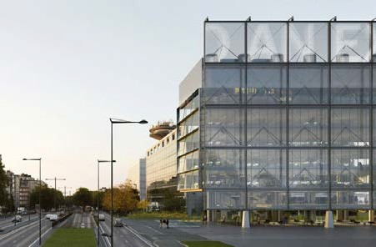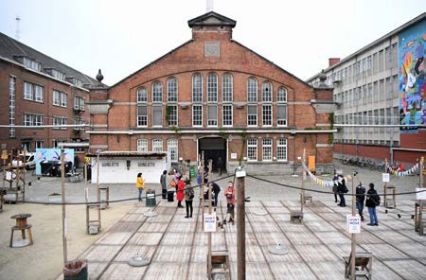

NEWS

@ Baukunst

**FRAME**

In July 2021, construction began of the «Frame» media house, located on the mediapark.brussels site. The Urban Development Corporation (sau-msi.brussels) plans to open it in 2023.

**USQUARE.BRUSSELS**

The first construction site began in December 2021, targeting seven emblematic buildings on the site. The various development phases of the site will continue until the end of 2023.

11



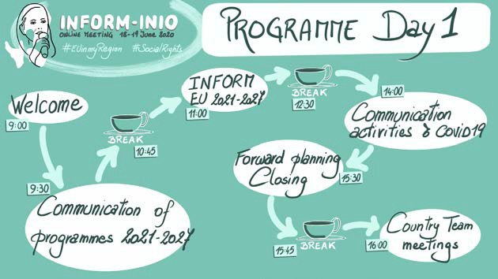

IN BRIEF

The ERDF Directorate has also re-launched its # EU IN MY REGION campaign, an agenda of activities linked to jointly funded projects in the Brussels-Capital Region! Free activities open to all during September and October!

**VIRTUAL INFORM MEETING June 2021!**

Participation in the virtual INFORM EU meeting, the European network of communication officers responsible for the communication of EU and Member States’ investments in shared management covering European funds. It should be mentioned that the Brussels-Capital Region took over the national coordination at the end of summer 2021.

12





**ROUNDTABLES** held at the end of 2021 brought together more than 35 projects on themes such as social cohesion, eco- construction, entrepreneurship, the circular economy and health.

The aim is sharing experiences and creating dialogue between projects, understanding how the ERDF has been able to stimulate new initiatives and existing or future collaborations that enhance ecosystems, linked to the selected themes. The results will be published and disseminated in 2022.

**2021-2027**

**THE NEW PROGRAMMING** was marked by the EU’s adoption of new regulations (investment priorities, funding conditions, etc.) relating to the cohesion policy for the coming years. Based on the strategic note validated by the Government of the Brussels-Capital Region and presented to the programming partners (advisory councils, etc.), a preliminary draft programme was drawn up by

the ERDF Directorate, in close collaboration with the office of the Minister-President (responsible for the ERDF programme), with the European Commission and several administrations and regional partner organisations.

13